CONFIDENTIAL  CS/NOV 2026/ICT450

UNIVERSITI TEKNOLOGI MARA
MARKING SCHEME

COURSE :
COURSE CODE :
EXAMINATION :
TIME :
DATABASE DESIGN AND DEVELOPMENT
ICT450
NOVEMBER 2026 (MOCK)
3 HOURS

MARKING SCHEME NOTES

- This marking scheme accompanies the ICT450 mock paper (November 2026).
Answers are unofficial model answers, not official UTM marking schemes.

- Marking points state the expected answer and the allocation of marks; every question retains its source paper and page reference.

- Five questions x 20 marks; total = 100 marks.
- Real-bank questions: 5. Placeholders: 0.
Questions and answers are for local study use only.

- Structure derived from 12 unique ICT450 past papers; every real question remains traceable to its source page.

FOR MARKERS' USE ONLY

This marking scheme consists of 7 printed pages.
MARKING GUIDE
QUESTION 1 (20 marks)
Source: ICT450-2019-JUN · page [2, 3] · bank id ICT450-2019-JUN-Q1
Reference answer
(a) Traditional file system and database redesign. [8 marks]
• i) Problems: data is duplicated across separate files; programs depend on file layouts; sharing and security are weak; the same update must be repeated in several files.
• ii) Database approach: integrate the separate files into one logical database managed by a DBMS, define a shared schema and keys, and let applications access data through the DBMS rather than through private files.
(b) Mobile database characteristics and SRC applications. [8 marks]
• Characteristics: location independence and ubiquitous access; synchronization with a central database; limited device resources.
• Application 1: a campus event and announcement app for students — SRC can push updates and students can read them anywhere.
• Application 2: a shuttle or campus facility status app — students see live locations and schedules.
• Reason: students carry mobile devices and need timely, location-aware information.
(c) Primary keys in the course schema. [4 marks]
• i) COURSE: CourseCode; SUBJECT: SubjectCode; TEACHER: TeacherCode; COURSE_SUBJECT: (CourseCode, SubjectCode).
• ii) A primary key uniquely identifies each row, prevents duplicate records and enforces entity integrity.
Marking guide
• a)(i) 4 marks for two file-system problems.
• a)(ii) 4 marks for a database redesign with shared schema/DBMS.
• b) 2 marks for each characteristic and 2 marks for each application/reason (8).
• c)(i) 2 marks for all primary keys; (ii) 2 marks for the purpose.
Provenance: model_unofficial · confidence high · Model-authored from the approved question text, the supplied source assets and the ICT200/ICT450 knowledge base; no official ICT450 marking scheme was supplied.
Knowledge base basis: TOPIC 1 DATABASE CONCEPT (1).pdf; TOPIC 2 DATA MODEL (1).pdf; TOPIC 3 RELATIONAL DATA MODELstu.pdf

QUESTION 2 (20 marks)
Source: ICT450-2022-FEB · page [3, 4] · bank id ICT450-2022-FEB-Q2
Reference answer
(a) Conceptual, logical and physical design. [8 marks]
• Conceptual design — an abstract, software-independent model of entities, attributes and relationships derived from business rules.
• Logical design — maps the conceptual model to the chosen data model (usually relational tables, keys and constraints); it is software-dependent.
• Physical design — selects storage structures, indexes, file organisation and access paths; it is hardware- and software-dependent.
(b) Four big-data characteristics with examples. [8 marks]
• Volume — very large amounts of data; example: billions of daily e-commerce clicks.
• Velocity — data arrives and must be processed quickly; example: real-time payment fraud alerts.
• Variety — many formats; example: text, images, video and sensor data in one platform.
• Veracity — uncertainty in data quality; example: noisy social-media posts that need cleaning.
• Value is also accepted as an extended characteristic.
(c) Two spreadsheet features different from a database. [4 marks]
• A spreadsheet has no enforced relationships, primary keys or referential integrity; a database enforces them.
• A spreadsheet has limited multi-user concurrency, security and recovery; a database provides transaction control and central access rights.
Marking guide
• a) 2 marks for each design stage and 2 marks for the software-dependence point (8).
• b) 2 marks for each of four characteristics with example (8).
• c) 2 marks for each difference (4).
Provenance: model_unofficial · confidence high · Model-authored from the approved question text, the supplied source assets and the ICT200/ICT450 knowledge base; no official ICT450 marking scheme was supplied.
Knowledge base basis: TOPIC 2 DATA MODEL (1).pdf; TOPIC 6 DATABASE DESIGN (1).pdf

QUESTION 3 (20 marks)
Source: ICT450-2023-FEB · page [4] · bank id ICT450-2023-FEB-Q3
Reference answer
The boarding schema contains a repeating group of flight and destination attributes for each customer booking.
(a) Define normalization and its importance. [3 marks]
• Normalization is the process of evaluating and correcting table structures to minimise redundancy and anomalies.
• It is important because it prevents insertion, update and deletion anomalies and keeps each fact in one place.
(b) Three requirements for good normalized tables. [6 marks]
• Each cell must be atomic and there must be no repeating groups; example: one row per boarding pass, not a list of flights in one cell.
• Every non-key attribute must depend on the whole primary key; example: customer name depends on CustIC, not on FlightID.
• There must be no transitive dependency; example: DestinationName must depend on DestinationID, not on FlightID through the destination.
(c) Normalise to 3NF. [11 marks]
1NF: expand the repeating group to one row per customer-flight-date; key (CustIC, FlightID, DateDepart).
2NF: remove customer, flight and destination partial dependencies.
2NF relations.
CUSTOMER (CustIC, CustFirstName, CustLastName)
FLIGHT (FlightID, PlaneType, Capacity, DestinationID)
DESTINATION (DestinationID, DestinationName)
BOARDING (CustIC, FlightID, DateDepart, DateArrive, TimeDepart, TimeArrive, Seat)
3NF: separate the flight schedule so date/time attributes depend on FlightID and DateDepart, not on the passenger.
3NF relations.
CUSTOMER (CustIC, CustFirstName, CustLastName)
DESTINATION (DestinationID, DestinationName)
FLIGHT (FlightID, PlaneType, Capacity, DestinationID)
FLIGHT_SCHEDULE (FlightID, DateDepart, DateArrive, TimeDepart, TimeArrive)
BOARDING (CustIC, FlightID, DateDepart, Seat)
Marking guide
• a) 3 marks: definition and importance.
• b) 6 marks: 2 marks for each requirement with example.
• c) 11 marks: 1NF (2), 2NF (4), 3NF (5).
Provenance: model_unofficial · confidence medium · Model-authored from the approved question text, the supplied source assets and the ICT200/ICT450 knowledge base; no official ICT450 marking scheme was supplied.
Knowledge base basis: TOPIC 5 NORMALIZATION (1).pdf
Assumptions / notes
• The curly braces in the printed schema denote a repeating group of flight/destination attributes.

QUESTION 4 (20 marks)
Source: ICT450-2023-JUL · page [4] · bank id ICT450-2023-JUL-Q4
Reference answer
Loan database schema.
DEPARTMENT (DeptID, DeptName)
APPLYLOAN (ClientNum, LoanID, LoanTotal, LoanRemainder, LoanDate)
LOAN (LoanID, LoanType, StaffID)
CLIENT (ClientNum, ClientName, ClientAddress, ClientPhoneNum)
OFFICER (StaffID, StaffName, DeptID)
(a) Create the APPLYLOAN table. [4 marks]
CREATE TABLE APPLYLOAN (
ClientNum VARCHAR(10) NOT NULL,
LoanID VARCHAR(10) NOT NULL,
LoanTotal DECIMAL(12,2),
LoanRemainder DECIMAL(12,2),
LoanDate DATE,
PRIMARY KEY (ClientNum, LoanID),
FOREIGN KEY (ClientNum) REFERENCES CLIENT (ClientNum),
FOREIGN KEY (LoanID) REFERENCES LOAN (LoanID)
);
(b) Client names with a personal loan, using a subquery. [4 marks]
SELECT ClientName
FROM CLIENT
WHERE ClientNum IN (
SELECT ClientNum
FROM APPLYLOAN
WHERE LoanID IN (
SELECT LoanID
FROM LOAN
WHERE LoanType = 'Personal'
)
);
(c) Total loan from 2021 until 2023. [4 marks]
SELECT SUM(LoanTotal) AS total_loan
FROM APPLYLOAN
WHERE LoanDate BETWEEN DATE '2021-01-01' AND DATE '2023-12-31';
(d) Officers managing housing loans in the finance department. [4 marks]
SELECT DISTINCT o.StaffName
FROM OFFICER o
JOIN LOAN l ON l.StaffID = o.StaffID
JOIN DEPARTMENT d ON d.DeptID = o.DeptID
WHERE l.LoanType = 'Housing'
AND d.DeptName = 'Finance';
(e) Total loan for each loan type. [4 marks]
SELECT l.LoanType, SUM(a.LoanTotal) AS total_loan
FROM LOAN l
JOIN APPLYLOAN a ON a.LoanID = l.LoanID
GROUP BY l.LoanType;
Marking guide
• a) 4 marks: columns (1), composite primary key (1), both foreign keys (2).
• b) 4 marks: nested subqueries and personal-loan filter.
• c) 4 marks: SUM and date range.
• d) 4 marks: three-table join, housing and finance filters.
• e) 4 marks: join, GROUP BY loan type, SUM.
Provenance: model_unofficial · confidence high · Model-authored from the approved question text, the supplied source assets and the ICT200/ICT450 knowledge base; no official ICT450 marking scheme was supplied.
Knowledge base basis: TOPIC 7 SQL.pdf
Assumptions / notes
• APPLYLOAN is an associative entity between CLIENT and LOAN with a composite key.

QUESTION 5 (20 marks)
Source: ICT450-2024-JAN · page [6] · bank id ICT450-2024-JAN-Q5
Reference answer
The ERD models officers, duties, summonses, students and offenses. OFFICER_DUTY records duty dates, and SUMMON_OFFENSE resolves the many-to-many summons-offense relationship.
(a) Construct the ERD with Crow's Foot notation. [16 marks]
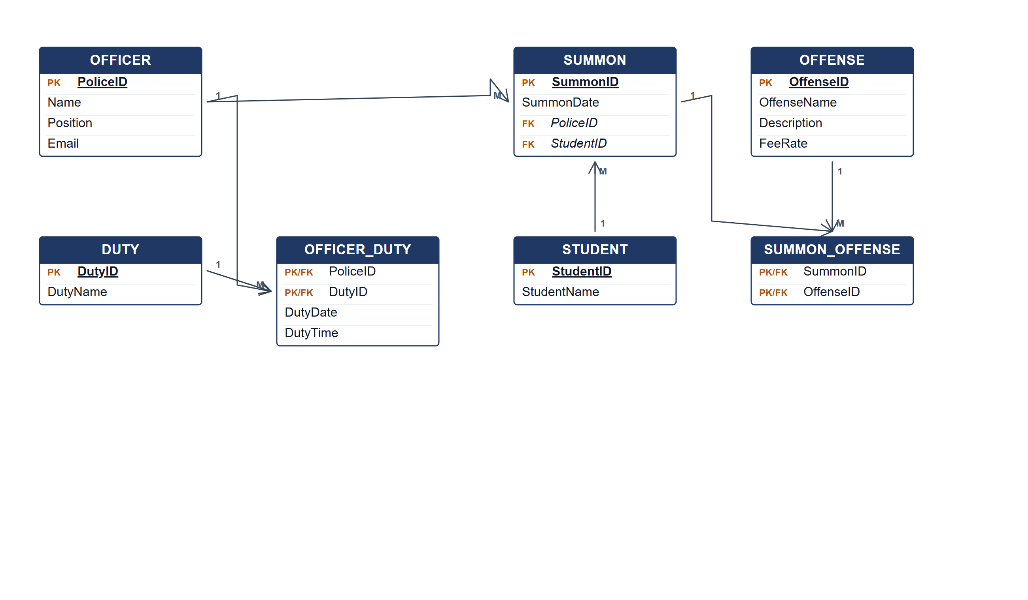
Auxiliary police ERD.
(b) Two pieces of information from the ERD. [4 marks]
• Which officers are assigned to each duty and when.
• Which offenses and fees are attached to each student summons.
Marking guide
• a) 16 marks: officer/duty/student (5); summon and offense (4); associative entities and relationships (5); keys (2).
• b) 2 marks for each information item (4).
Provenance: model_unofficial · confidence medium · Model-authored from the approved question text, the supplied source assets and the ICT200/ICT450 knowledge base; no official ICT450 marking scheme was supplied.
Knowledge base basis: TOPIC 4 ERD_stu (2).pdf; TOPIC 3 RELATIONAL DATA MODELstu.pdf
Assumptions / notes
• Each summon is issued by one officer to one student and contains one or more offenses; duty assignment carries the date and time.

